**Experiment No: 04**

# Experiment Name: Static NAT configuration in Packet Tracer

**Network Configuration:**

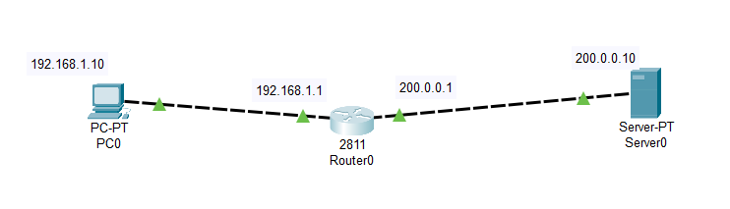

**Working procedure:**

1. First build the network topology according to above network
2. Then configure basic IP addressing on the router, PC and server.

**Router**

* enable
* config terminal
* int fa 0/0
* ip add 192.168.1.1 255.255.255.0
* no shutdown
* exit
* int fa 0/1
* ip add 200.0.0.1 255.255.255.0
* no shutdown
* exit
* **PC0:**IP add 192.168.1.10    Subnet mask 255.255.255.0 Default gateway 192.168.1.1
* **Server:**IP add 200.0.0.10 Subnet mask 255.255.255.0 Default gateway 200.0.0.1

Now, to configure static NAT on the router, these are the steps:

* Configure private/public IP address mapping using IP NAT inside source static PRIVATE_ID PUBLIC_ID command.
* Configure the router’s inside interface using IP NAT inside command.
* Configure the router’s outside interface using IP NAT outside command.

Here are the configuration commands:

* ip nat inside source static 192.168.1.10 155.21.21.10
* int fa0/0
* ip nat inside
* exit
* int fa0/1
* ip nat outside

**Result:**

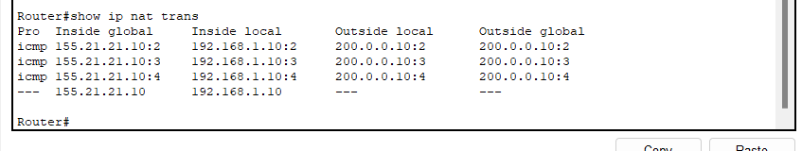

**Experiment No: 07**

**Experiment Name:** Basic OSPF Configuration

**Network Configuration:**

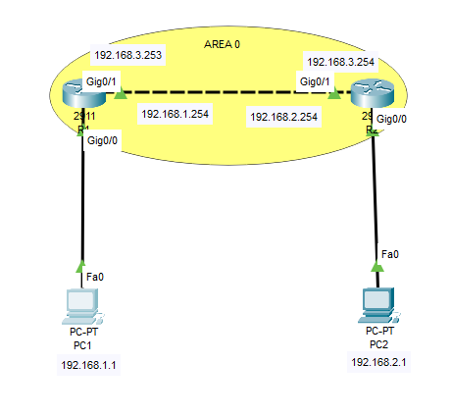

**Working procedure:**

1. First build the network topology according to above network
2. Then configure basic IP addressing on the router, PC and server.

**Router1**

* enable
* configure terminal
* hostname R1
* interface GigabitEthernet0/0
* ip address 192.168.1.254 255.255.255.0
* no shutdown
* interface g0/1
* ip address 192.168.3.253 255.255.255.0
* no shutdown
* exit

**Router2**

* enable
* configure terminal
* hostname R2
* interface GigabitEthernet0/0
* ip address 192.168.2.254 255.255.255.0
* no shutdown
* interface g0/1
* ip address 192.168.3.254 255.255.255.0
* no shutdown
* exit

**Host IP configurations**

* **PC1:** IP add: 192.168.1.1 Default gateway: 192.168.1.254
* **PC2:** IP add: 192.168.2.1 Default gateway 192.168.2.254

**Here are the OSPF configuration commands for the router:**

**Router1**

* router ospf 1
* network 192.168.1.0 0.0.0.255 area 0
* network 192.168.3.0 0.0.0.255 area 0
* exit

**Router2**

* router ospf 2
* network 192.168..0 0.0.0.255 area 0
* network 192.168.3.0 0.0.0.255 area 0
* exit